**Hiring channels for entering the data science field**

Linked in

**Companies’ Job boards**

<https://www.reed.co.uk/>

1. [Kaggle Job Board](https://www.kaggle.com/jobs)
2. 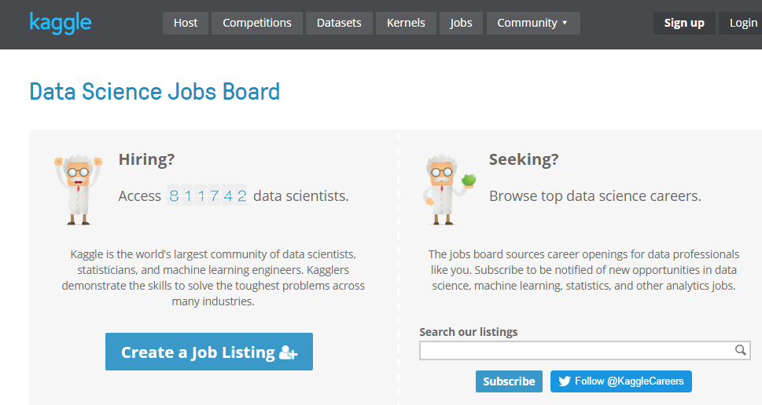

Data Elixer:

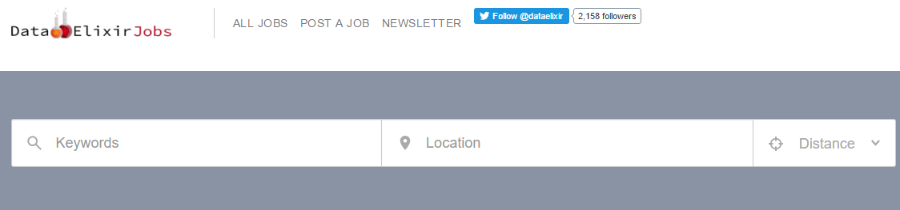

Analytics Talent:

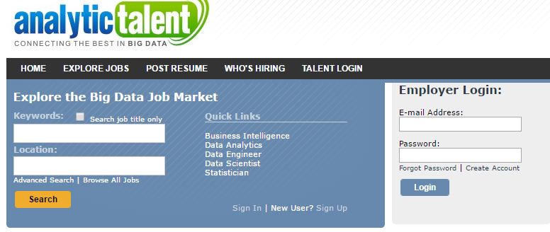

KDnuggets:

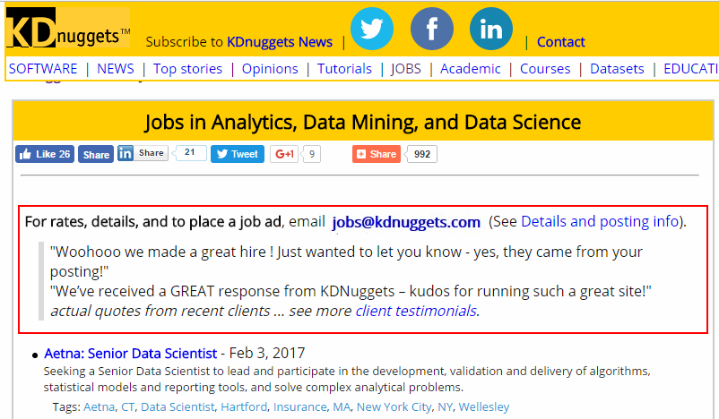

R users:

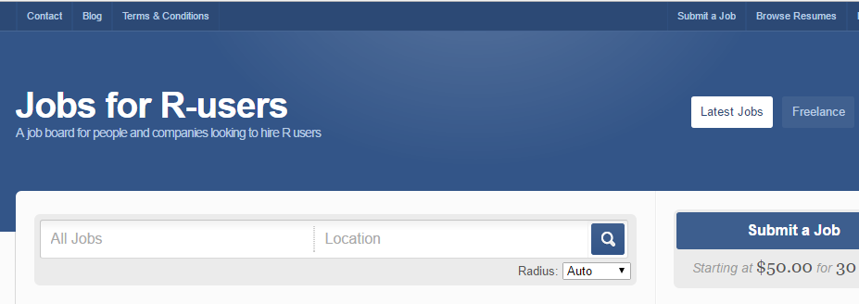

1. [**IcrunchData**](https://icrunchdata.com/find-jobs/)



1. [**DataWerq**](https://www.datawerq.com/)

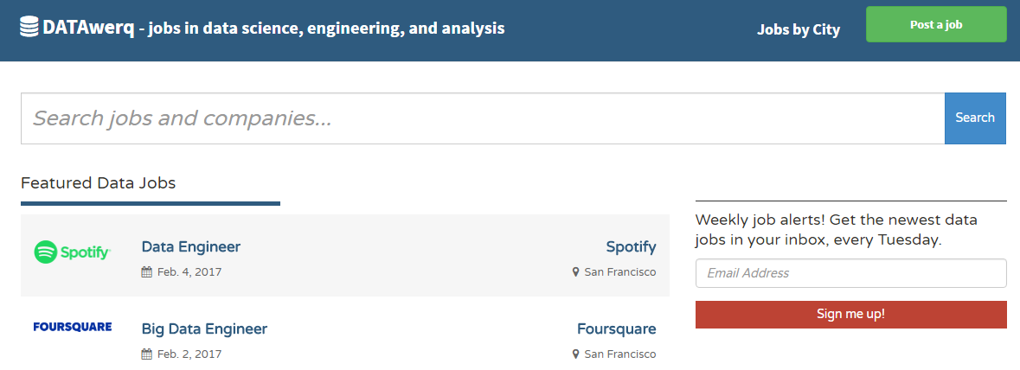

1. [**DataJobs**](https://datajobs.com/)
2. 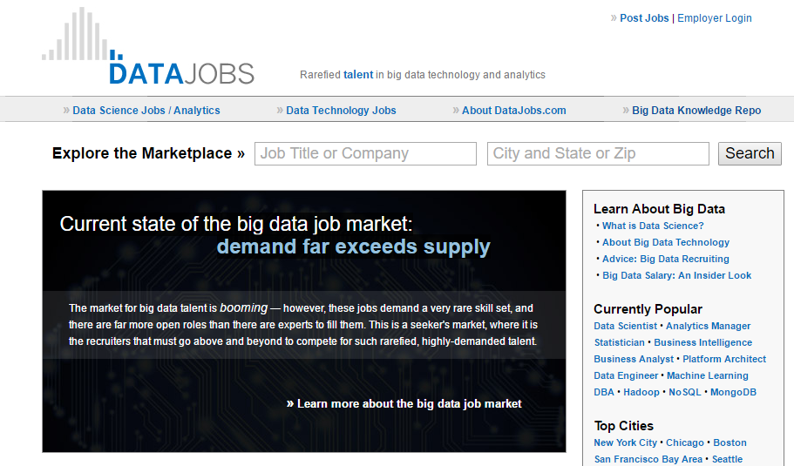

2.      [Reed](https://www.reed.co.uk/)

3.      [Monster](https://www.monster.co.uk/)

4.      [Guardian](https://jobs.theguardian.com/)

5.      [efinancialcareers](https://www.efinancialcareers.co.uk/" \t "_blank)

20 other web sites:

https://www.springboard.com/blog/data-science-jobs/?lipi=urn%3Ali%3Apage%3Ad\_flagship3\_pulse\_read%3BUjQLFWbiRGmiAsmjhG%2B8Fg%3D%3D